

CSA0506-Database Management Systems

ASSESSMENT TOOL 1

Activity Tool : Short Answer (High)

Ashmi P S
192571004
1. UPS Product Tracking Information System
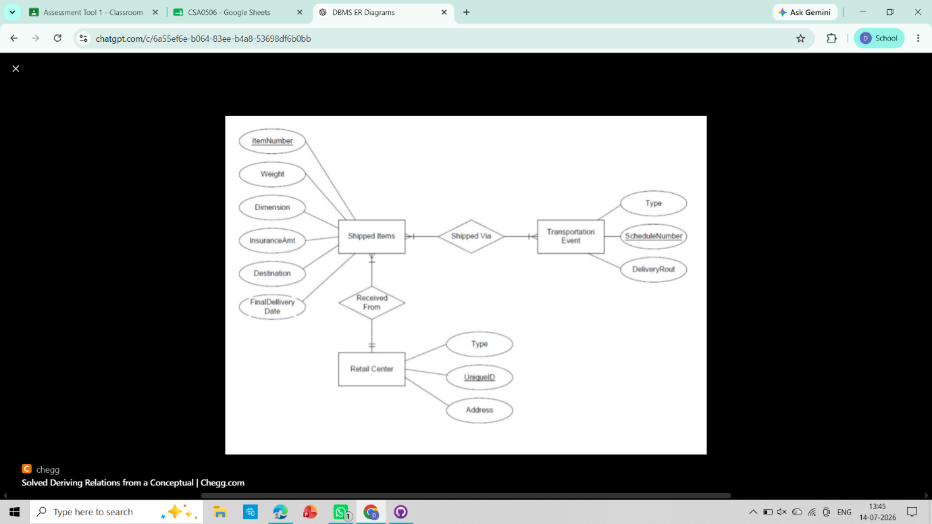

2. Course Management System
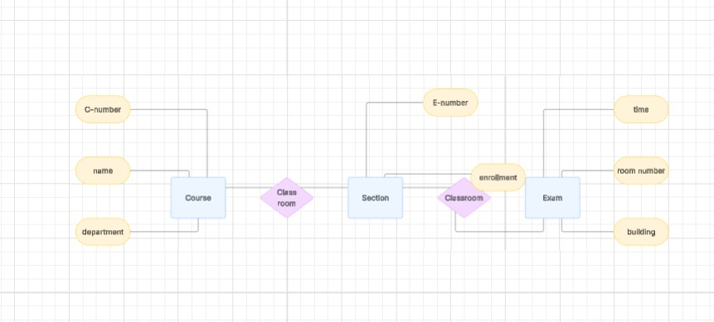

3. University Registrar’s Office Management System
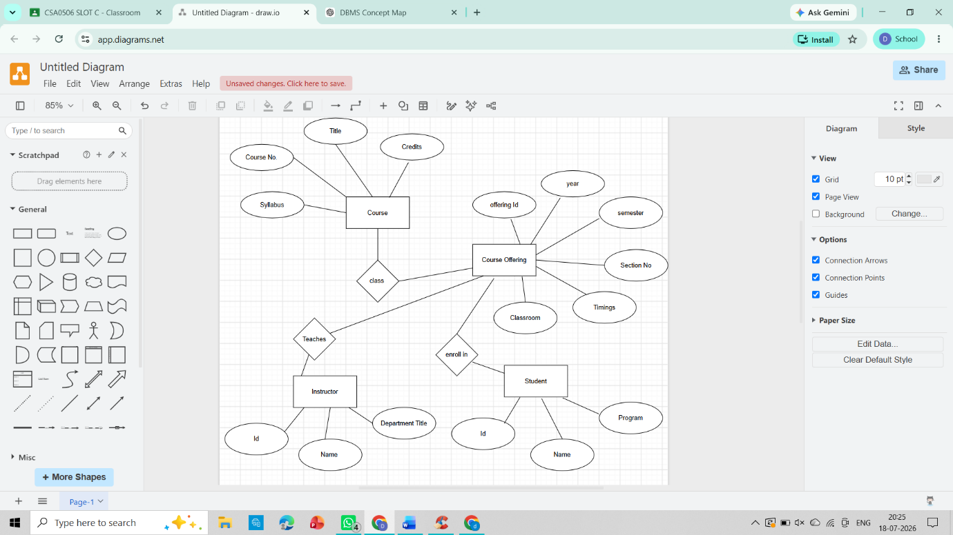

4. Hospital Management System

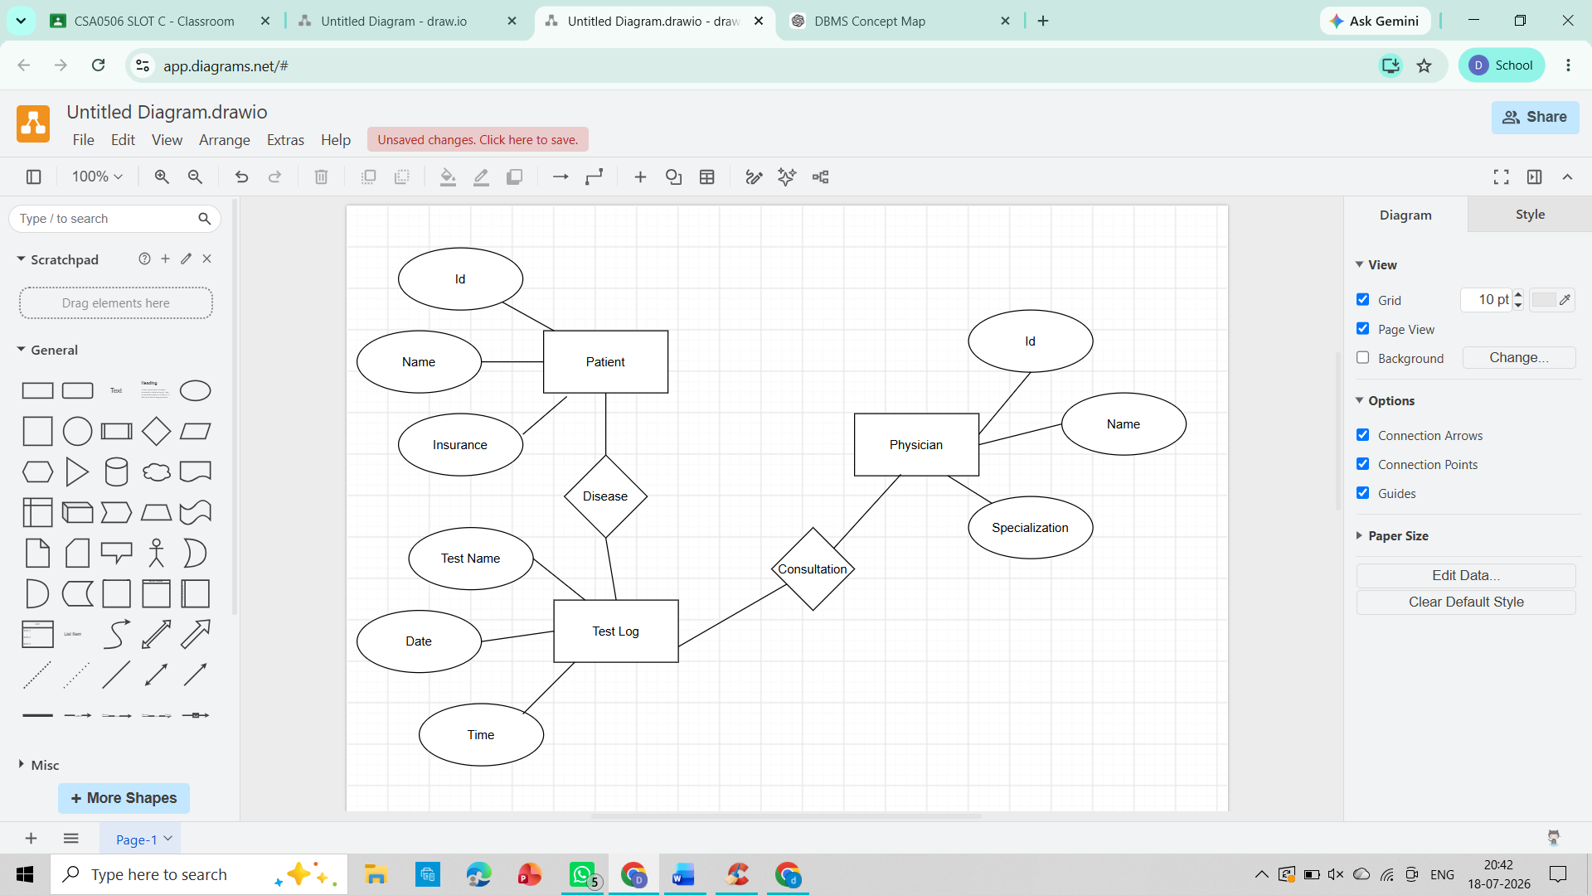

5. Company Project Management System
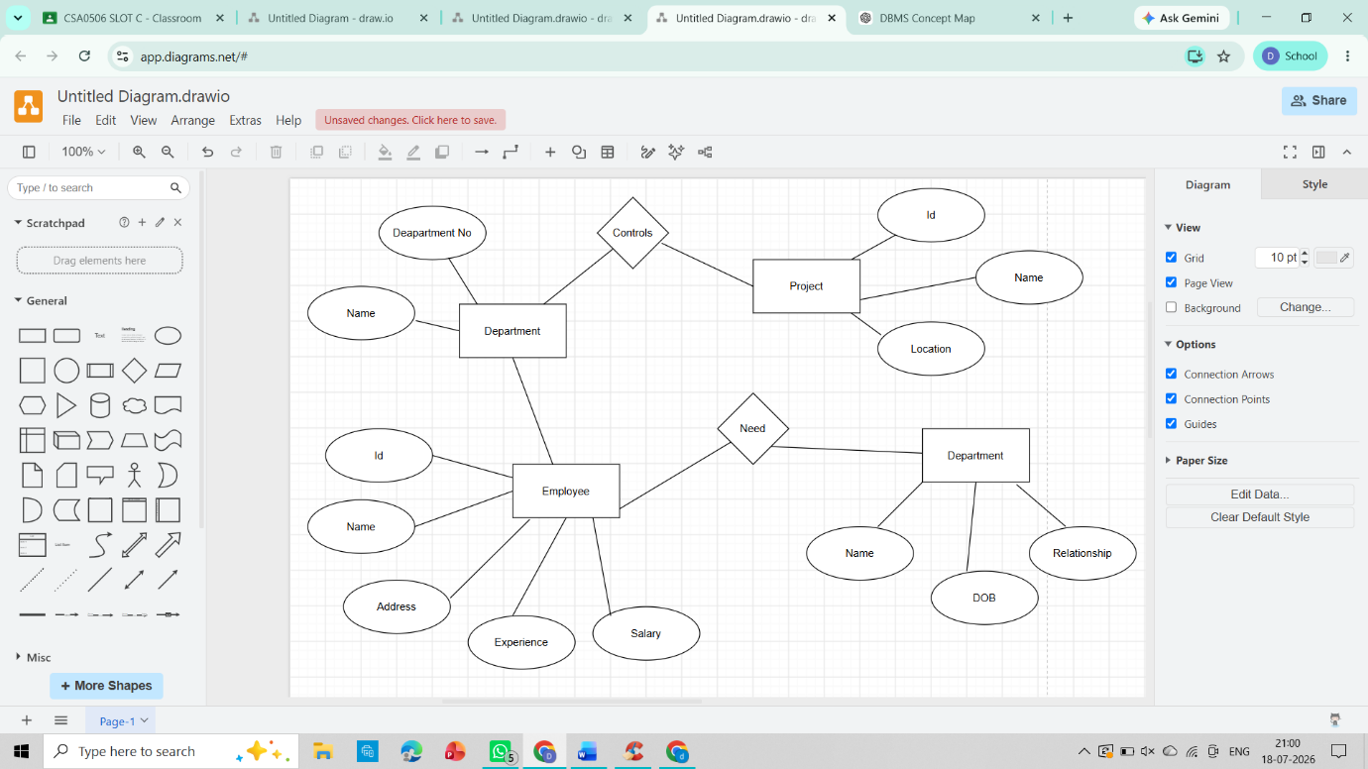

6. Schema and Instance
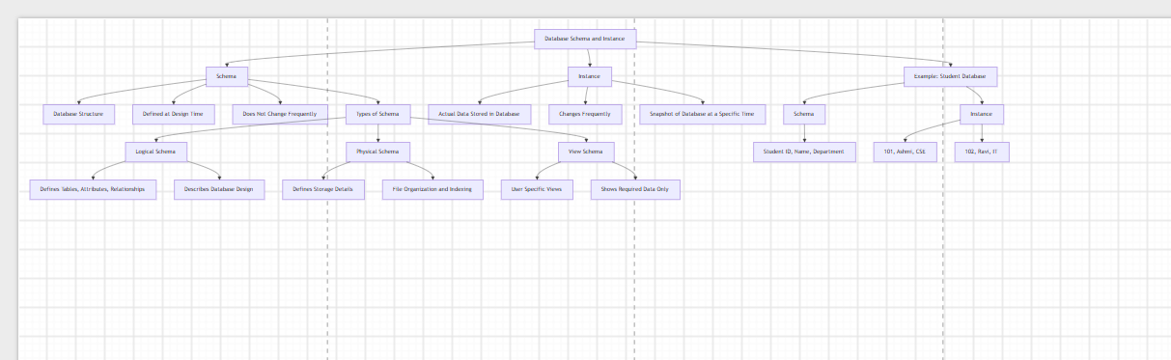

7. The entities, attributes, and relationships for a Bank Management System
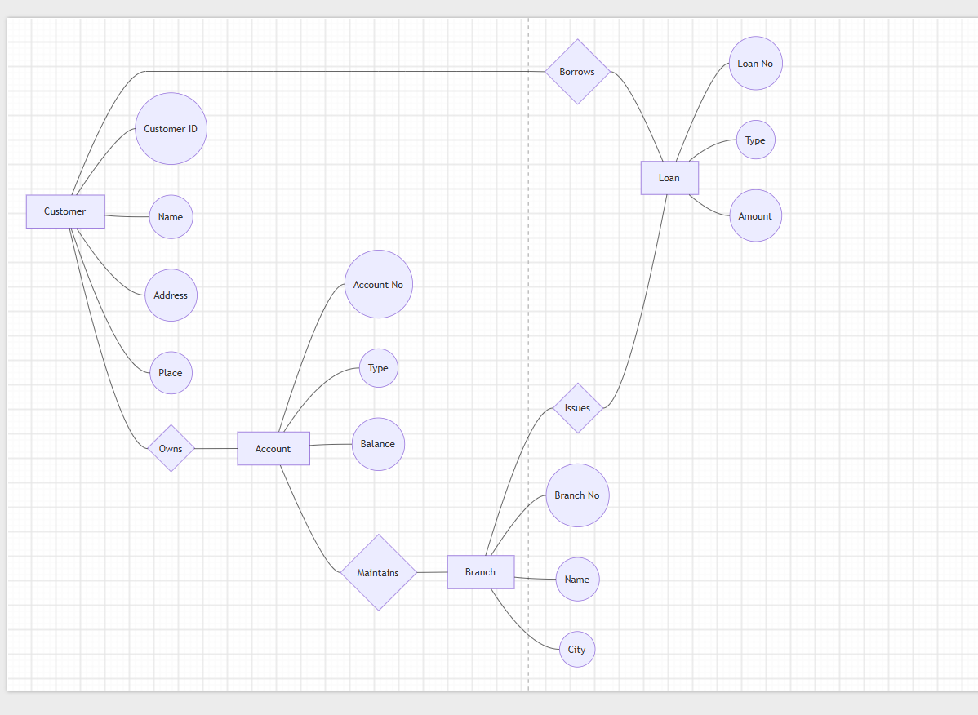

8. Extended ER (EER) Model
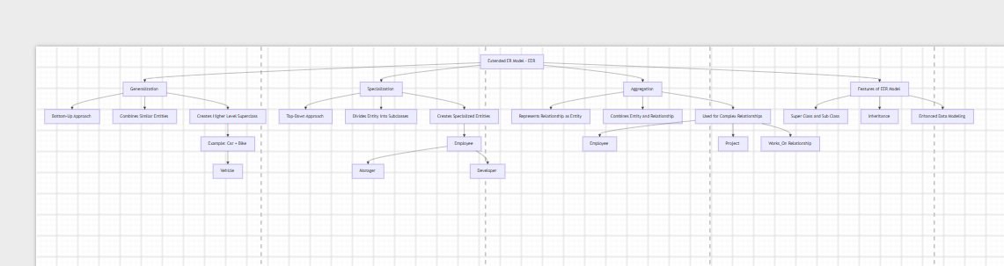

9. Hospital Management System

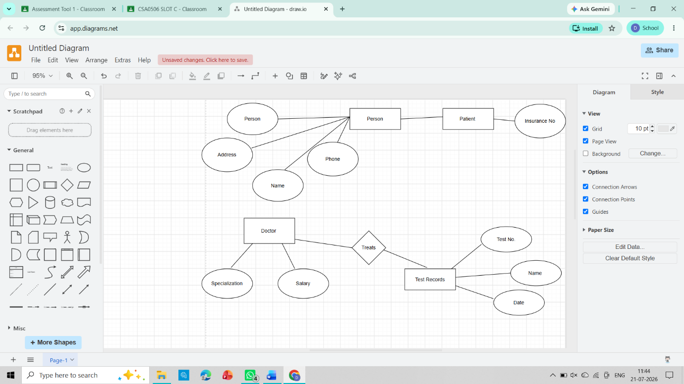

10. Design a concept map for the roles and responsibilities in a DBMS environment: DBA, End User, Application Developer.

